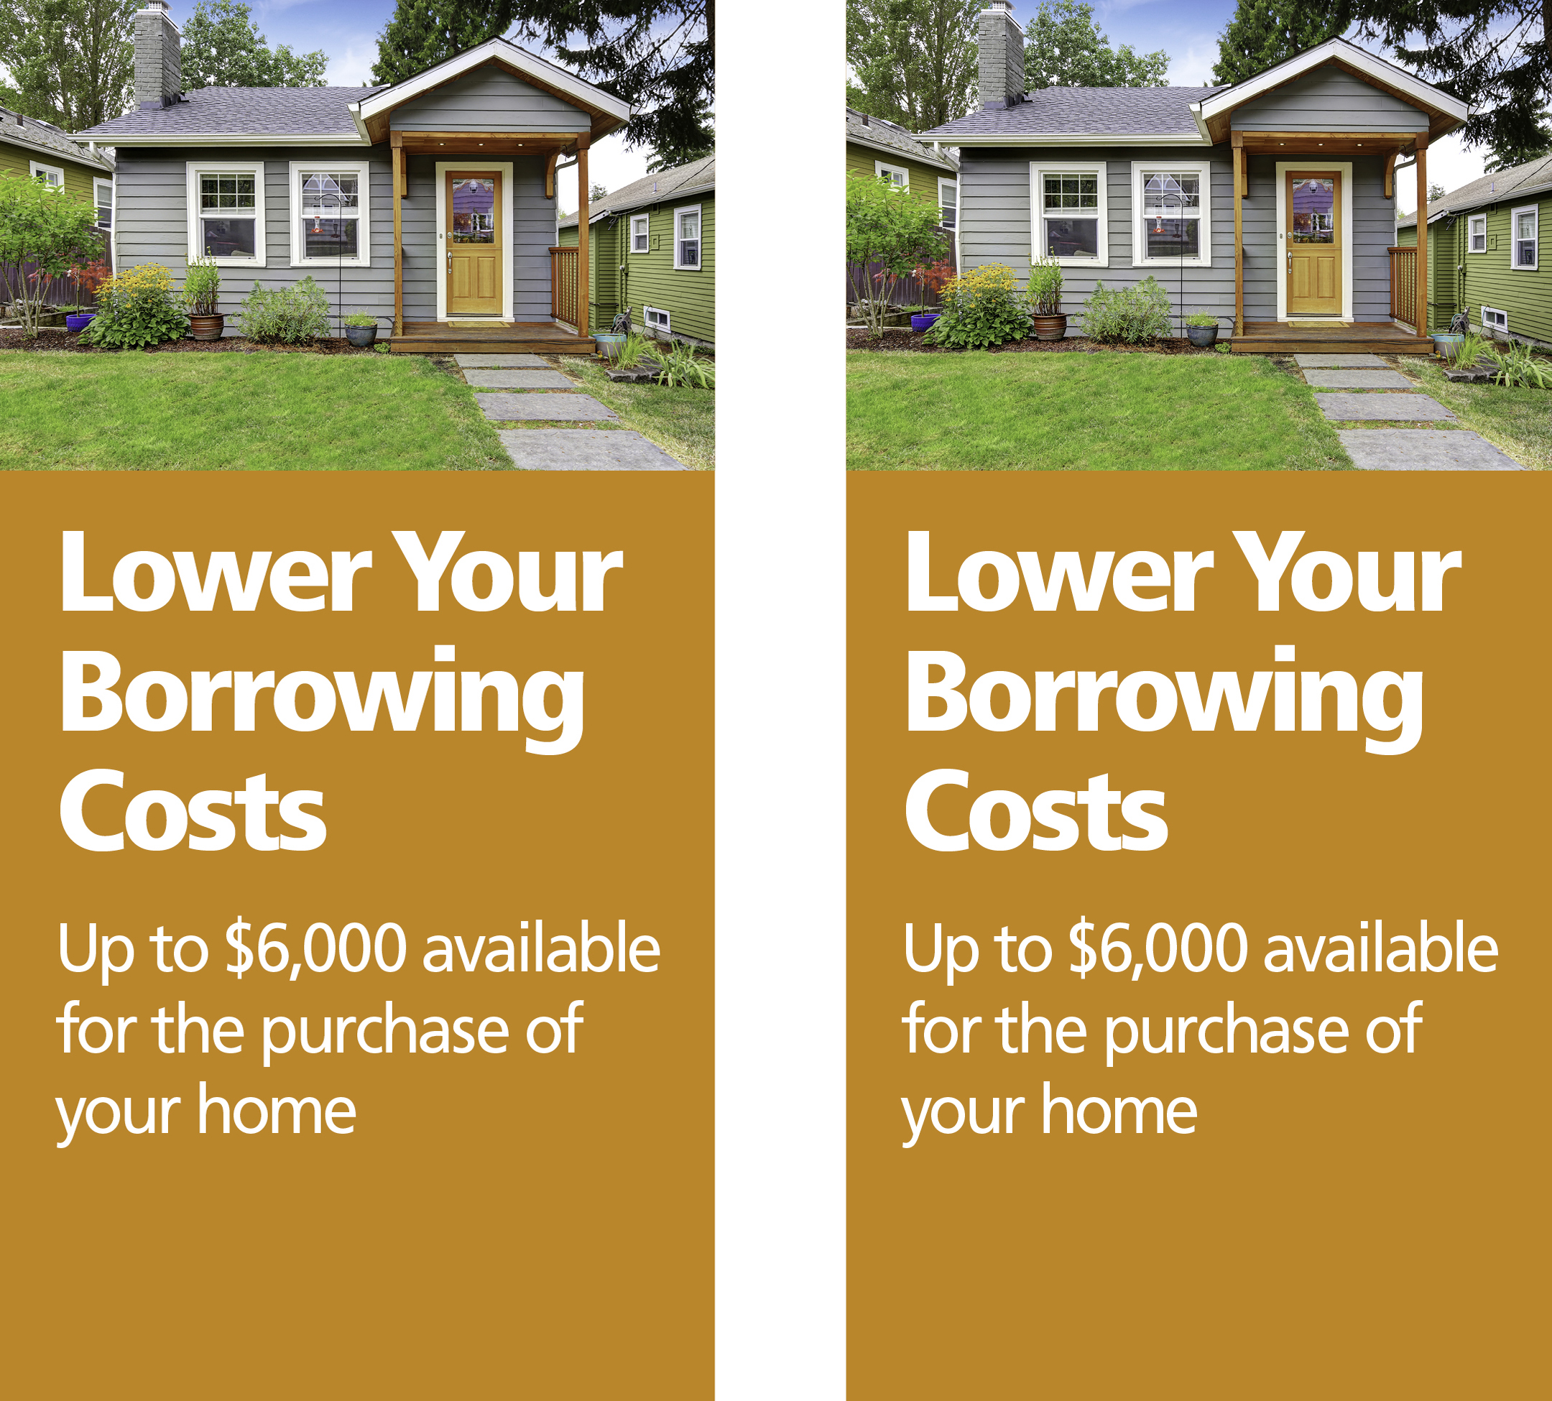

Your contact information goes here

Your disclosure information goes here

INSERT YOUR LOGO HERE

Your contact information goes here

Your disclosure information goes here

INSERT YOUR LOGO HERE

If you want to buy a home and have a steady income and good credit, [INSERT YOUR NAME HERE] and the Federal Home Loan Bank of Chicago can help.

Through the Downpayment Plus® Program\*, up to $6,000 may be available to eligible homebuyers in 2017 to use toward down payment and closing costs. Ask one of our loan officers today about the Downpayment Plus Program to see if you are eligible.

Homebuyers must meet income eligibility requirements and:

* Contribute at least $1,000 to the purchase of the home
* Participate in pre-purchase homebuyer counseling
* Live in the home as your primary residence

[INSERT YOUR NAME HERE] is committed to helping our neighbors. We can help lower your borrowing costs if you qualify for the Downpayment Plus Program. In 2017, you could receive up to $6,000 for the purchase of a home!

\* Downpayment Plus is a program from the Federal Home Loan Bank of Chicago. Restrictions apply. Please see the Federal Home Loan Bank of Chicago’s website at www.fhlbc.com for complete requirements. “Downpayment Plus” is a registered trademark of the Federal Home Loan Bank of Chicago.

INSERT YOUR LOGO HERE

If you want to buy a home and have a steady income and good credit, [INSERT YOUR NAME HERE] and the Federal Home Loan Bank of Chicago can help.

Through the Downpayment Plus® Program\*, up to $6,000 may be available to eligible homebuyers in 2017 to use toward down payment and closing costs. Ask one of our loan officers today about the Downpayment Plus Program to see if you are eligible.

Homebuyers must meet income eligibility requirements and:

* Contribute at least $1,000 to the purchase of the home
* Participate in pre-purchase homebuyer counseling
* Live in the home as your primary residence

[INSERT YOUR NAME HERE] is committed to helping our neighbors. We can help lower your borrowing costs if you qualify for the Downpayment Plus Program. In 2017, you could receive up to $6,000 for the purchase of a home!

\* Downpayment Plus is a program from the Federal Home Loan Bank of Chicago. Restrictions apply. Please see the Federal Home Loan Bank of Chicago’s website at www.fhlbc.com for complete requirements. “Downpayment Plus” is a registered trademark of the Federal Home Loan Bank of Chicago.

INSERT YOUR LOGO HERE