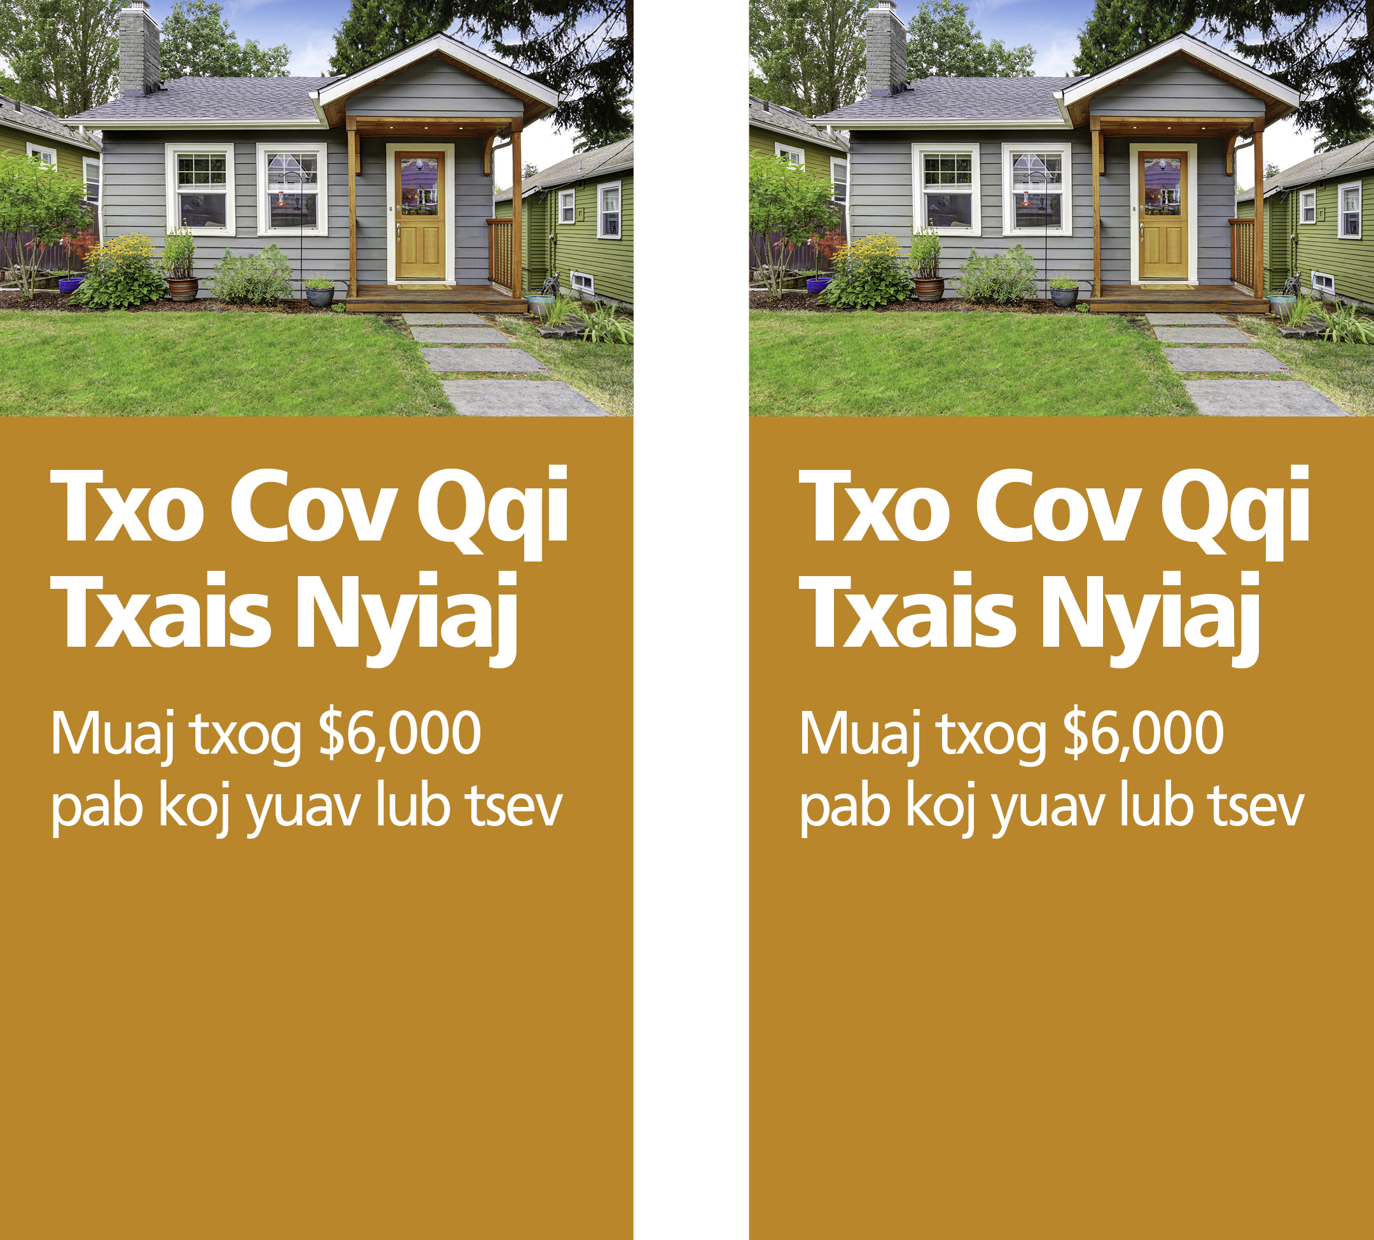

TSO KOJ DAIM DUAB NTAWM NO

Sau koj lub npe thiab xov tooj rau ntawm no

Sau koj cov lus yuav nthuav tawm rau ntawm no

Sau koj lub npe thiab xov tooj rau ntawm no

Sau koj cov lus yuav nthuav tawm rau ntawm no

TSO KOJ DAIM DUAB NTAWM NO

Yog koj xav yuav tsev thiab khwv tau nyiaj tsis tu ncua thiab muaj keeb kwm them nqi zoo (good credit), [TSO KOJ LUB NPE NTAWM NO] tej zaum Federal Home Loan Bank of Chicago yuav pab tau.

Nyob hauv qhov kev pab Downpayment Plus® Program\*, tej zaum yuav muaj txog $6,000 pab rau cov neeg tsim nyog (eligible) yuav tau tsev nyob rau xyoo 2017 coj los siv them qhov nyiaj them ua ntej (down payment) thiab cov nqi kaw tsev (closing costs). Nug peb ib tug neeg ua hauj lwm (loan officers) hnub no hais txog qhov kev pab Downpayment Plus Program seb koj puas tsim nyog yuav tau txais.

Cov neeg yuav tsev yuav tsum tau nyiaj tsis tshaj li txoj cai teev tseg thiab:

* Rho yus ntiag tug nyiaj tsis tsawg tshaj $1,000 los them lub tsev
* Koom kev kawm txog kev yuav tsev thiab paub txog nyiaj txiag
* Lub tsev koj yuav yuav tsum yog lub koj nyob

[TSO K[TSO KOJ LUB NPE NTAWM NO] lees los pab cov neeg nyob hauv zej zog. Peb yuav pab txo tau koj cov nyiaj txais los yuav tsev yog tias koj tsim nyog tau txais kev pab (qualify) ntawm Downpayment Plus Program. Nyob rau xyoo 2017, tej zaum koj kuj yuav tau txais txog $6,000 los yuav ib lub tsev!

\* Downpayment Plus is a program from the Federal Home Loan Bank of Chicago. Restrictions apply. Please see the Federal Home Loan Bank of Chicago’s website at www.fhlbc.com for complete requirements. “Downpayment Plus” is a registered trademark of the Federal Home Loan Bank of Chicago.

TSO KOJ DAIM DUAB NTAWM NO

Yog koj xav yuav tsev thiab khwv tau nyiaj tsis tu ncua thiab muaj keeb kwm them nqi zoo (good credit), [TSO KOJ LUB NPE NTAWM NO] tej zaum Federal Home Loan Bank of Chicago yuav pab tau.

Nyob hauv qhov kev pab Downpayment Plus® Program\*, tej zaum yuav muaj txog $6,000 pab rau cov neeg tsim nyog (eligible) yuav tau tsev nyob rau xyoo 2017 coj los siv them qhov nyiaj them ua ntej (down payment) thiab cov nqi kaw tsev (closing costs). Nug peb ib tug neeg ua hauj lwm (loan officers) hnub no hais txog qhov kev pab Downpayment Plus Program seb koj puas tsim nyog yuav tau txais.

Cov neeg yuav tsev yuav tsum tau nyiaj tsis tshaj li txoj cai teev tseg thiab:

* Rho yus ntiag tug nyiaj tsis tsawg tshaj $1,000 los them lub tsev
* Koom kev kawm txog kev yuav tsev thiab paub txog nyiaj txiag
* Lub tsev koj yuav yuav tsum yog lub koj nyob

[TSO K[TSO KOJ LUB NPE NTAWM NO] lees los pab cov neeg nyob hauv zej zog. Peb yuav pab txo tau koj cov nyiaj txais los yuav tsev yog tias koj tsim nyog tau txais kev pab (qualify) ntawm Downpayment Plus Program. Nyob rau xyoo 2017, tej zaum koj kuj yuav tau txais txog $6,000 los yuav ib lub tsev!

\* Downpayment Plus is a program from the Federal Home Loan Bank of Chicago. Restrictions apply. Please see the Federal Home Loan Bank of Chicago’s website at www.fhlbc.com for complete requirements. “Downpayment Plus” is a registered trademark of the Federal Home Loan Bank of Chicago.

TSO KOJ DAIM DUAB NTAWM NO